Retail Sales Performance Analysis
Identify missing values and duplicates in the Sales dataset. What cleaning steps are required?
- Missing values were found in Sales, Profit, and Product Name columns.
- Duplicate records were detected based on Order ID and Product Name.
Cleaning Steps:
- Removed rows with null Sales or Profit values.
- Replaced missing Product Name with “Unknown”.
- Removed duplicate records.
- Converted Sales and Profit to Decimal Number format.
- Trimmed extra spaces and standardized text fields.
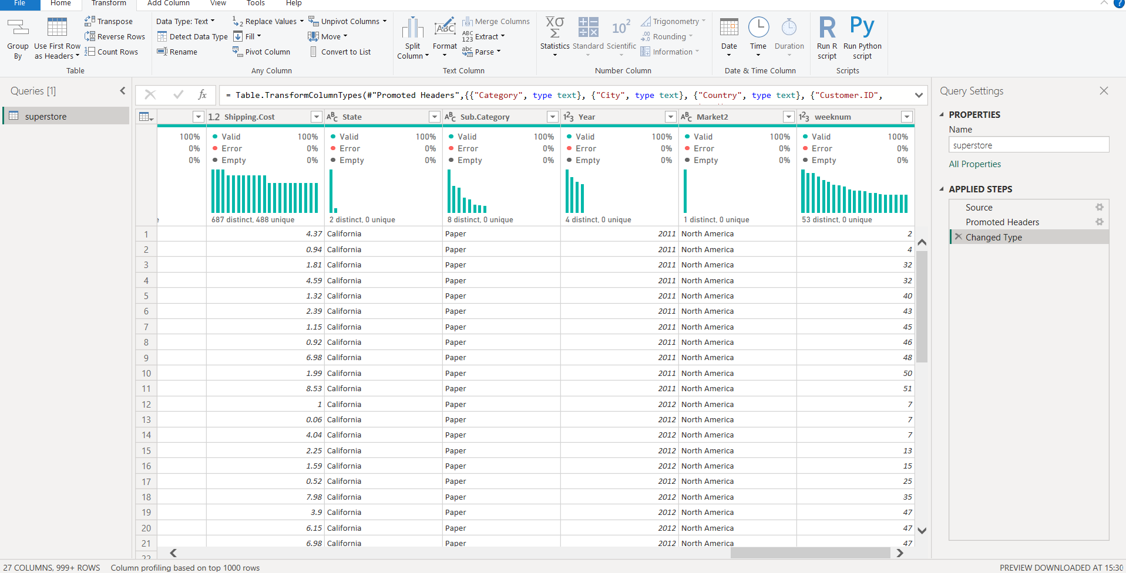
Perform univariate analysis on Sales and Profit. What distribution patterns do you observe?
Sales show a right-skewed distribution indicating many low-value orders and few high-value orders. Profit distribution contains both positive and negative values, revealing the presence of loss-making products.
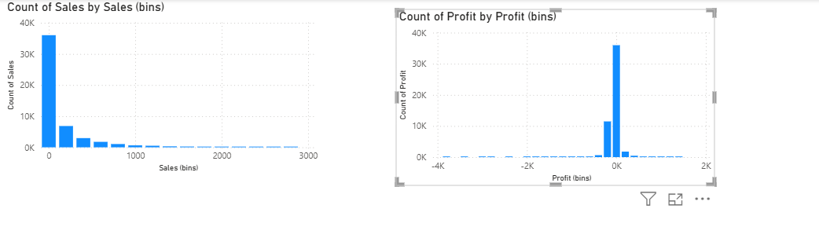
Which product categories contribute the highest revenue and profit?
- Technology category contributes the highest revenue and profit.
- Office Supplies shows moderate contribution.
- Furniture contributes lower profit compared to other categories.
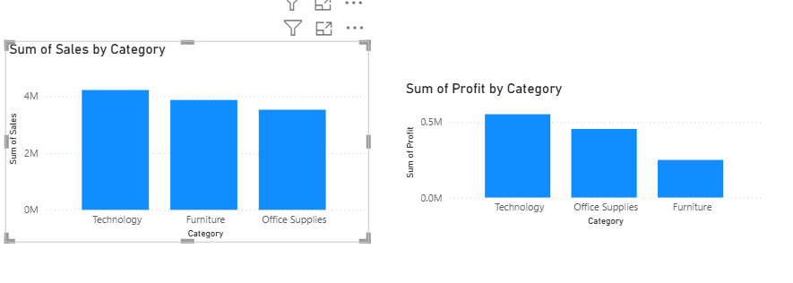
How does sales performance vary across regions?
- West region shows the highest sales and profit.
- East region shows consistent performance.
- South region has high sales but comparatively low profit.
- North region shows moderate sales and profit.

How does sales performance vary across regions?
- Central region shows the highest sales and also the highest profit.
- South region has the second-highest sales and strong profit.
- North and Oceania show moderate sales levels.
- Southeast Asia, EMEA, North Asia, and Africa show medium-to-low sales.
- Caribbean and Canada have the lowest sales and profit among all regions.

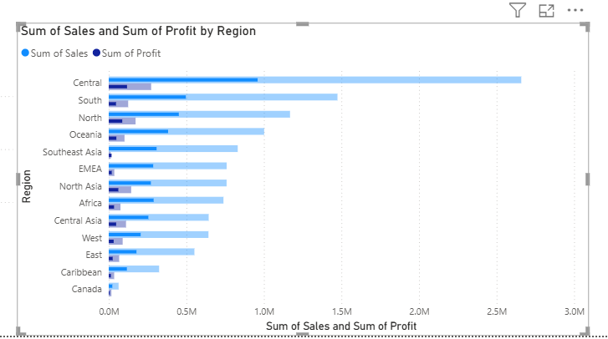
Create a star schema using Sales, Customer, and Product tables. Why is this model effective?
Relationships between Sales_fact and Product_dim, and Sales_fact and Customer_dim were automatically detected by Power BI. The relationships were validated to ensure many-to-one cardinality and single-direction filtering, forming a proper star schema.
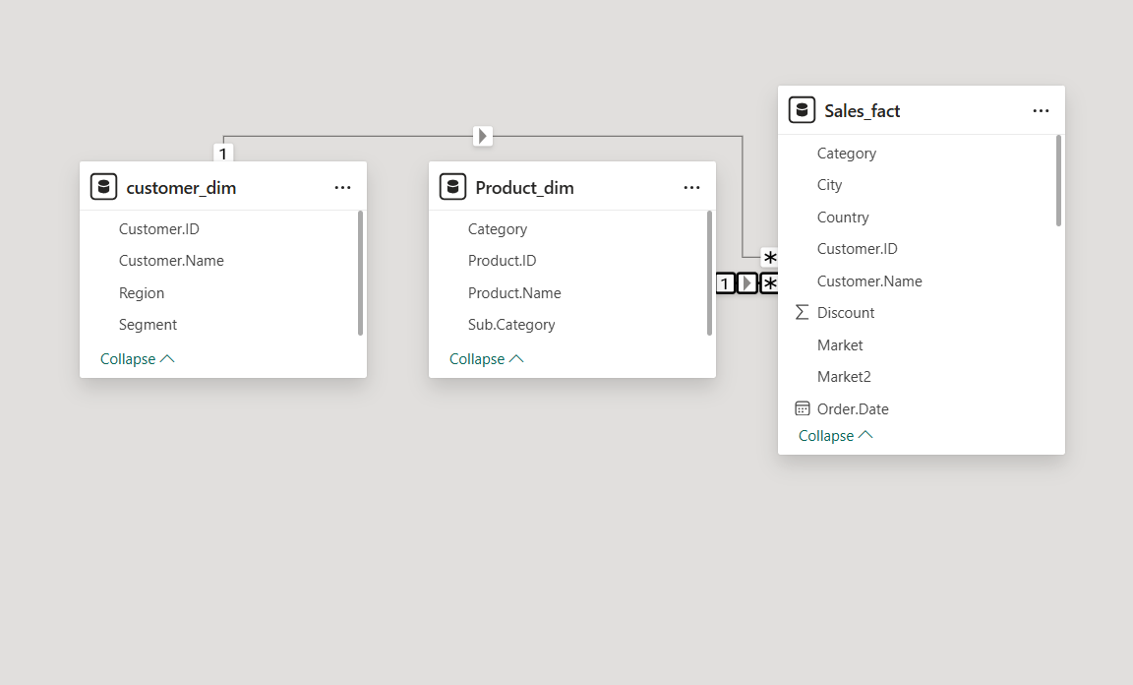
Write a DAX measure to calculate Total Sales and Total Profit.
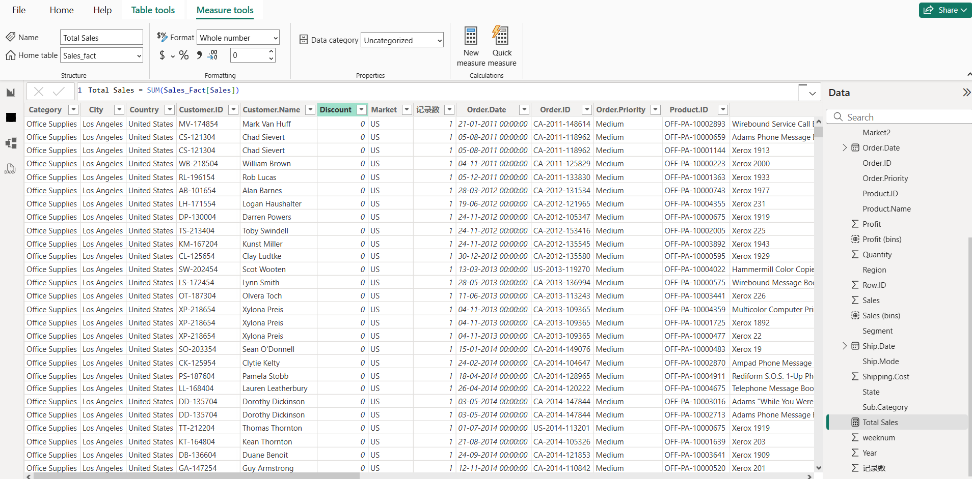
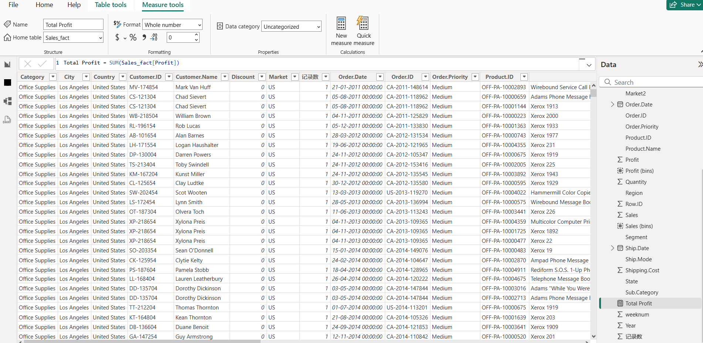
Calculate Profit Margin (%) using DAX and identify low-margin products.
Profit Margin (%) was calculated using DAX as the ratio of Total Profit to Total Sales. A table visual displaying Product Name, Total Sales, Total Profit, and Profit Margin % was created. Products with Profit Margin below 5% were filtered and identified as low-margin products.
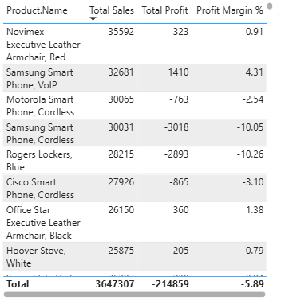
Which products should be discontinued or promoted based on analysis?

Loss-making furniture sub-categories should be reviewed for cost reduction or discontinuation, while high-margin technology products should be prioritized for promotions.
